PIN’s with Modifiers on GRM but no entries in Revobjsitemodifier Table

**14751022800000**

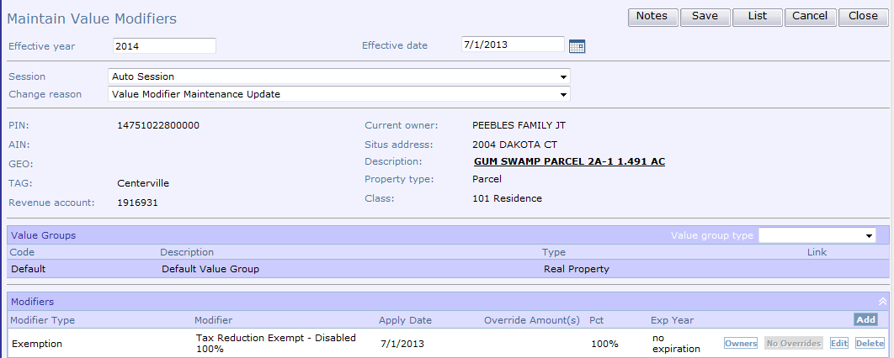

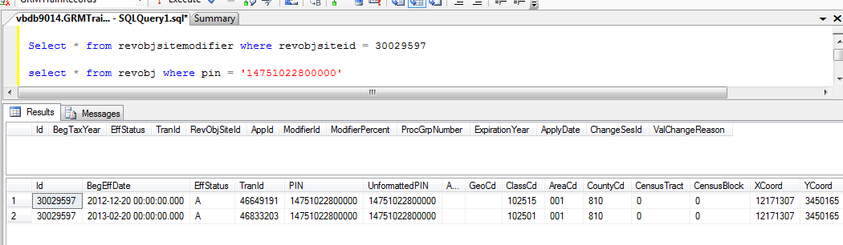

**13981630180000**

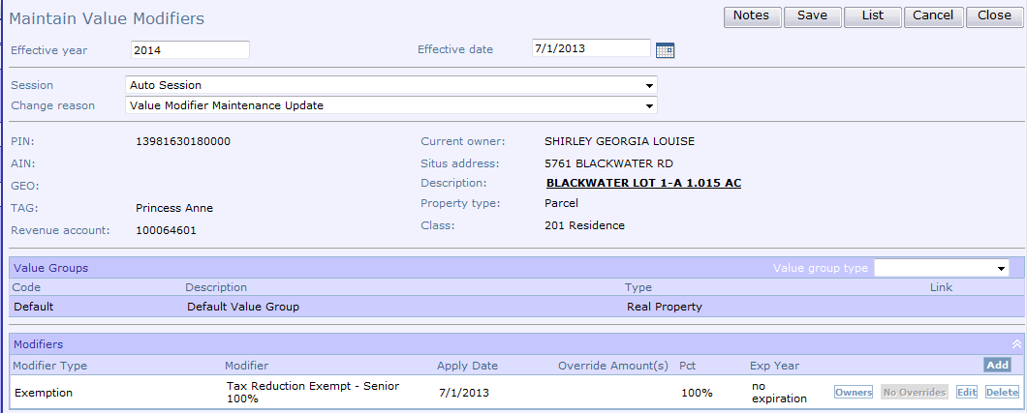

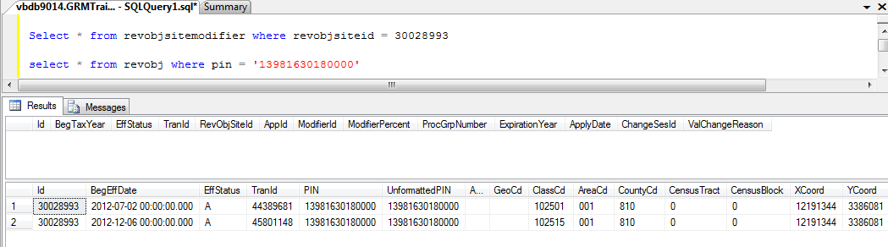

**14767154810313**

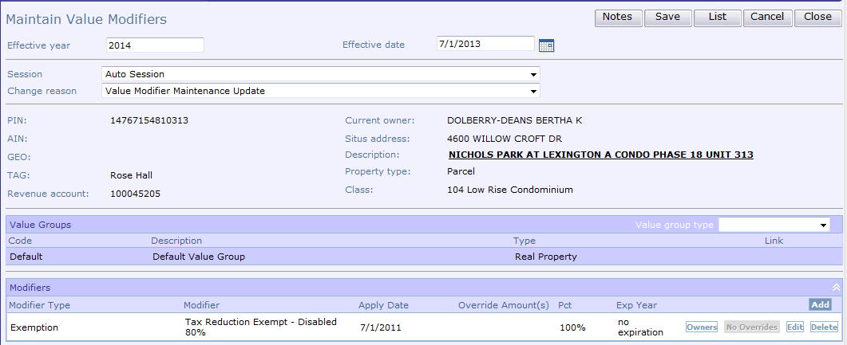

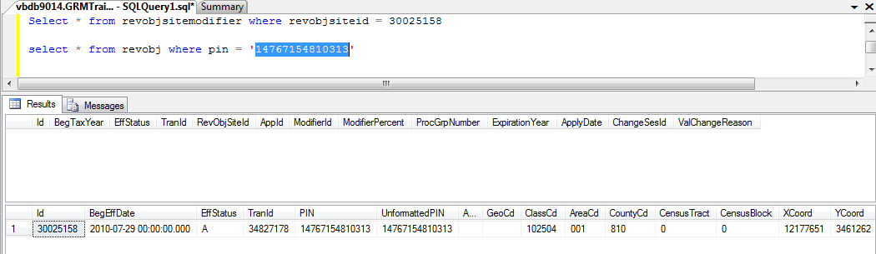

**14688318361636**

